

SAMEH System Report

ASsesment 1

C3282367| C3304608 | C3304485 | C3303256

SENG2130 | 11/4/2019

# Contents –

* Q1 Use Case Diagram
* Q2 Use Case Descriptions
* Q3 Activity Diagrams
* Q4 Domain Class Diagram

**Question 1 –**

1. **List of all use cases with brief descriptions**

* Organise Lease Terms and Costs
  + Allows the manager to create a new lease for a customer.
* Schedule Maintenance
  + A piece of equipment is scheduled for maintenance.
* Extend Lease
  + Allows an increase in the length of time a customer can hire equipment for.
* Check Jobs
  + The maintenance staff go to or call the main office to get a list of jobs to be completed.
* Give Out Equipment
  + Allows equipment to be booked out and used by the customer.
* Give Out Equipment from Warehouse/Workshop
  + Allows equipment to be picked up from the warehouse or workshop.
* Return Equipment
  + Warehouse staff collects equipment from customer, checks fuel and stores it back in the warehouse.
* Check Fuel Levels
  + The warehouse staff checks the level of returned equipment to make sure it has been returned with a full tank.
* Service Equipment
  + The warehouse staff services a piece of equipment.
* Provide Information to Customer
  + When requested by the customer over the phone, the office staff tells them the requested details.

1. **Use Case Diagram**

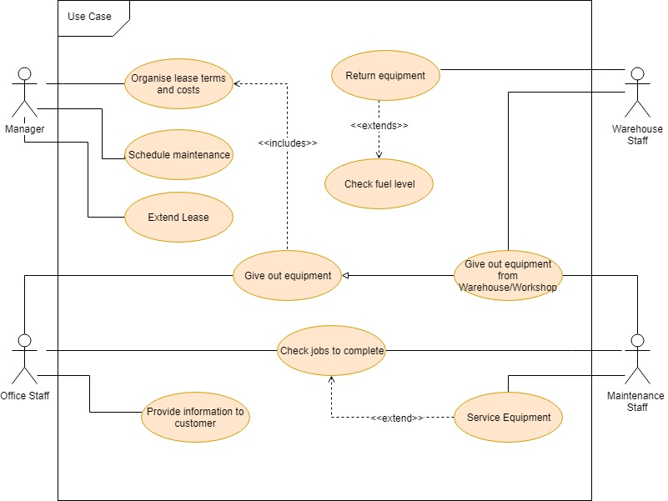

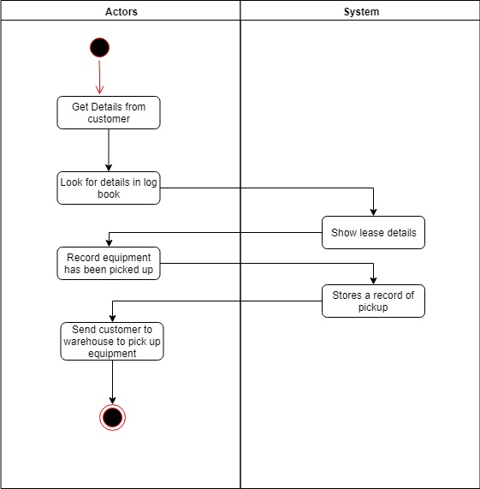

**Question 2 – Fully Developed Use Case Descriptions**

Organise Lease Terms and Costs – Use Case Description

|  |  |
| --- | --- |
| Use Case Name | Organise Lease Terms and Costs |
| Brief Description | allows the manager create a new lease for a customer |
| Actors | Manager |
| Related use cases | N/A |
| Entry condition | A lease has been requested by a customer |
| Exit condition | Lease is assigned to a customer and written into the logbook |
| Flow of events | |  |  | | --- | --- | | Actors | System | | 1. Customer details entered to logbook  2. Lease terms written in logbook, and the customer assigned to the lease  3. Manager writes product to be leased in the logbook | 1.1 Customer details stored in logbook  2.1 Lease terms stored in logbook      3.1 Product to be leased stored in the logbook | |
| Except condition | N/A |

Schedule Maintenance – Use Case Description

|  |  |
| --- | --- |
| Use Case Name | Schedule Maintenance |
| Brief Description | A piece of equipment is scheduled a date for maintenance |
| Actors | Manager |
| Related use cases | N/A |
| Entry condition | A piece of equipment requires maintenance |
| Exit condition | A date is set aside for the equipment to be repaired |
| Flow of events | |  |  | | --- | --- | | Actors | System | | 1. Manager writes equipment that needs to be maintained into the office logbook and the date it needs to be repaired | 1.1 Maintenance information stored in office logbook | |
| Except condition | N/A |

Extend Lease – Use Case Description

|  |  |
| --- | --- |
| Use Case Name | Extend Lease |
| Brief Description | Allows an increase in the length of time a customer can hire a piece of equipment for. |
| Actors | Manager |
| Related use cases | N/A |
| Entry condition | A customer wishes to hire a piece of equipment for longer |
| Exit condition | The end date of the lease is extended |
| Flow of events | |  |  | | --- | --- | | Actors | System | | 1. Manager finds original lease details in the office logbook  2. Manager edits original lease date, changing it to the agreed upon later date | 1.1 Logbook shows original lease information  2.1 Logbook stores the new lease information | |
| Except condition | N/A |

Check Jobs – Use Case Description

|  |  |
| --- | --- |
| Use Case Name | Check jobs |
| Brief Description | The maintenance staff go to or call to the main office to get a list of jobs to be completed |
| Actors | Maintenance and Office Staff |
| Related use cases | N/A |
| Entry condition | Maintenance staff needs to check jobs they have to do |
| Exit condition | Maintenance staff finds out the jobs they have to do |
| Flow of events | |  |  | | --- | --- | | Actors | System | | 1. Maintenance Staff enters/ calls main office, requesting jobs  2. Office Staff checks office logbook for jobs  3. Office Staff tells Maintenance Staff what jobs need to be done | 2.1 Logbook shows jobs required to be done by maintenance | |
| Except condition | N/A |

Give out Equipment – Use Case Description

|  |  |
| --- | --- |
| Use Case Name | Give out Equipment |
| Brief Description | Allows equipment to be booked out and used by the customer |
| Actors | Office Staff |
| Related use cases | 'Give out Equipment from Warehouse/Workshop' is a generalization of 'Give out Equipment' |
| Entry condition | A customer wishes to book out a piece of equipment |
| Exit condition | Customer receives equipment and the book-out is recorded |
| Flow of events | |  |  | | --- | --- | | Actors | System | | 1. Get details from customer  2. Look for customers lease details in logbook  3. Record that the equipment has been picked up in logbook  4. Send customer to warehouse to collect equipment | 2.1 Show respective lease details    3.1 Logbook stores record of pickup | |
| Except condition | N/A |

Give out Equipment from Warehouse/Workshop – Use Case Description

|  |  |
| --- | --- |
| Use Case Name | Give out Equipment from Warehouse/Workshop |
| Brief Description | Allows equipment to be picked up from the warehouse or the workshop |
| Actors | Warehouse Staff, Maintenance Staff |
| Related use cases | Generalization of 'Give out Equipment' |
| Entry condition | A customer wishes to book out a piece of equipment |
| Exit condition | Customer receives equipment and the book-out is recorded |
| Flow of events | |  |  | | --- | --- | | Actors | System | | 1. Get details from customer    2. Record that the equipment has been picked up in logbook  3. Give customer equipment | 1.1 Store customers details in logbook  2.1 Stores record of pickup | |
| Except condition | N/A |

Return Equipment – Use Case Description

|  |  |
| --- | --- |
| Use Case Name | Return Equipment |
| Brief Description | Warehouse Staff collects equipment from customer, checks fuel and stores it back in the warehouse |
| Actors | Warehouse Staff |
| Related use cases | <<extend>> -> 'Check Fuel Levels' |
| Entry condition | Customer wishes to return a piece of equipment |
| Exit condition | Fuel is checked and equipment put into storage |
| Flow of events | |  |  | | --- | --- | | Actors | System | | 1. Get equipment from customer  2. Check Fuel  3. Write the return of the equipment into the logbook  4. Put equipment back in storage | 3.1 Stores return details in logbook | |
| Except condition | N/A |

Check Fuel Levels – Use Case Description

|  |  |
| --- | --- |
| Use Case Name | Check Fuel Levels |
| Brief Description | The Warehouse Staff checks the level of returned equipment to make sure it has been returned with a full tank |
| Actors | Warehouse Staff |
| Related use cases | Extends from 'Return Equipment' |
| Entry condition | Equipment has been returned and fuel needs to be checked |
| Exit condition | Fuel level is checked and recorded |
| Flow of events | |  |  | | --- | --- | | Actors | System | | 1. Check fuel level of the returned equipment | 1.1 Fuel level recorded in logbook | |
| Except condition | N/A |

Service Equipment – Use Case Description

|  |  |
| --- | --- |
| Use Case Name | Service equipment |
| Brief Description | The warehouse staff services a piece of equipment |
| Actors | Maintenance Staff |
| Related use cases | <<extends>> -> Check Jobs |
| Entry condition | Piece of equipment has been recorded as needing to be serviced |
| Exit condition | Piece of equipment is serviced |
| Flow of events | |  |  | | --- | --- | | Actors | System | | 1. Check Jobs  2. Service equipment  3. Write in warehouse logbook that equipment has been serviced | 3.1 Warehouse logbook stores equipment service date/details | |
| Except condition | N/A |

Provide Information To Customer – Use Case Description

|  |  |
| --- | --- |
| Use Case Name | Provide information to customer |
| Brief Description | When requested by the customer over the phone, the office staff tells them the requested details |
| Actors | Main Office |
| Related use cases | N/A |
| Entry condition | Customer requests details from the main office |
| Exit condition | Details are explained over the phone |
| Flow of events | |  |  | | --- | --- | | Actors | System | | 1. Get question from customer  2. Find relevant information in logbook  3. Give information to customer | 2.1 Show relevant information when found | |
| Except condition | N/A |

**Question 3 – Activity Diagrams for Each Use Case**

Organise Lease Terms and Costs – Activity Diagram

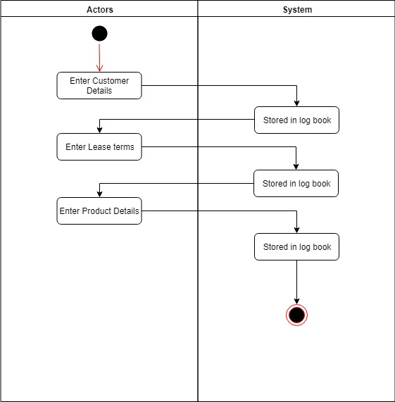

Schedule Maintenance - Activity Diagram

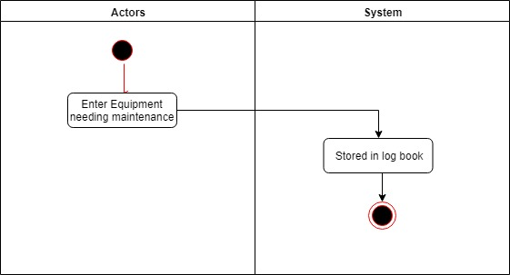

Extend Lease - Activity Diagram

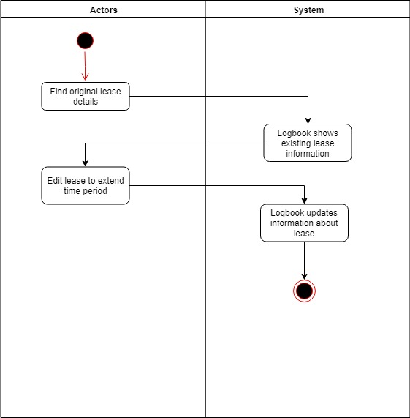

Check Jobs - Activity Diagram

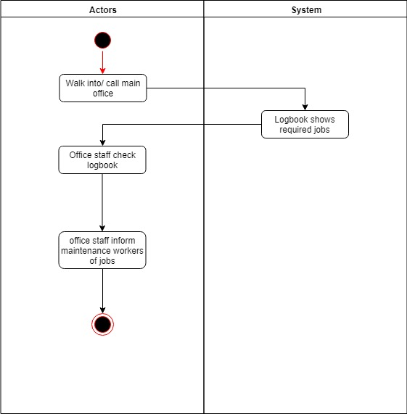

Give Out Equipment - Activity Diagram 

Give Out Equipment From Workshop - Activity Diagram

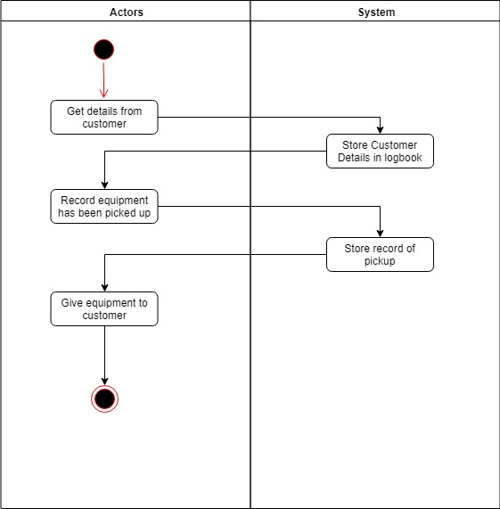

Return Equipment - Activity Diagram

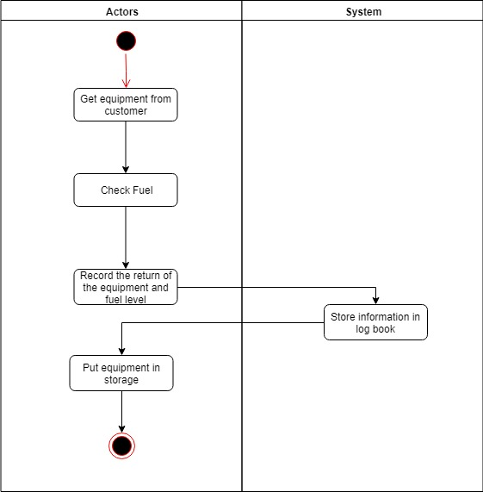

Check Fuel Levels - Activity Diagram

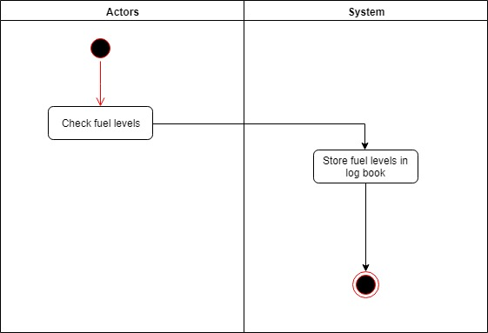

Service Equipment - Activity Diagram

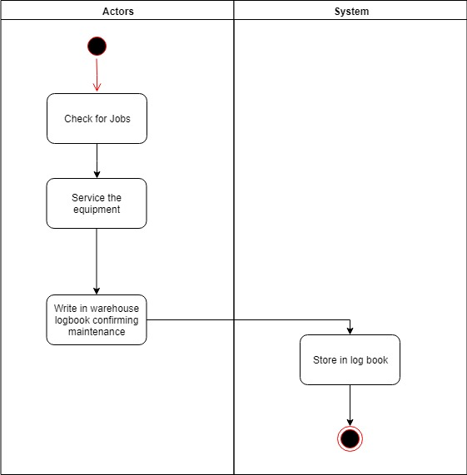

Provide Information to Customer - Activity Diagram

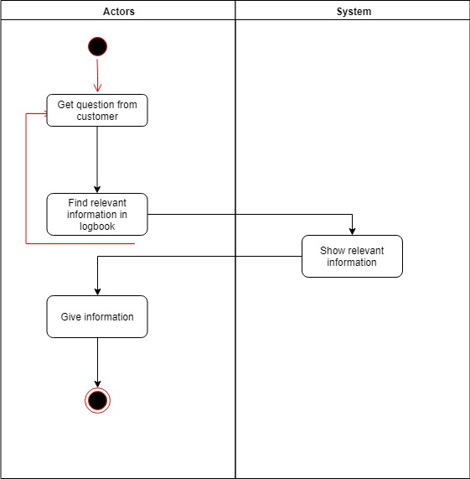

**Question 4 – Class Diagram**

